Joins Practice:

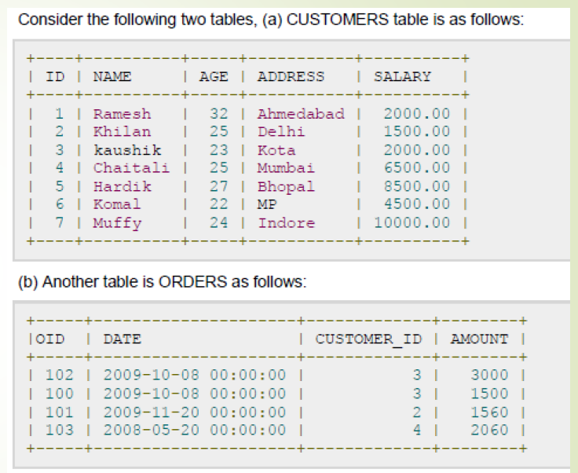

SHOW CUSTOMER NAMES , AMOUNT, SALARY if they have placed order

INNER JOIN:

A type of join that combines rows from two or more tables based on a related column between them and returns the rows where there is a match.

SELECT NAME , ORDERS.AMOUNT , SALARY

FROM CUSTOMERS

INNER JOIN ORDERS

ON CUSTOMERS.ID = ORDERS.CUSTOMER_ID ;

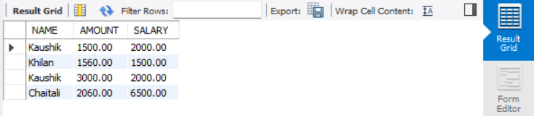

LEFT JOIN:

A LEFT JOIN returns all rows from the left table (the first table mentioned in the query), along with matching rows from the right table

SELECT NAME , ORDERS.AMOUNT , SALARY

FROM CUSTOMERS

LEFT JOIN ORDERS

ON CUSTOMERS.ID = ORDERS.CUSTOMER_ID ;

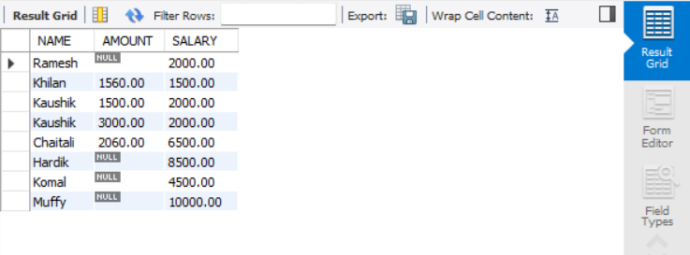

RIGHT JOIN:

A RIGHT JOIN returns all rows from the RIGHT table (the first table mentioned in the query), along with matching rows from the LEFT table

SELECT NAME , ORDERS.AMOUNT , SALARY

FROM CUSTOMERS

RIGHT JOIN ORDERS

ON CUSTOMERS.ID = ORDERS.CUSTOMER_ID ;

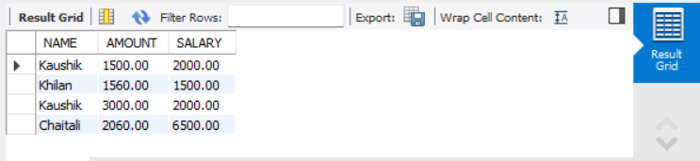

NATURAL JOIN:

No need of providing the ON condition, this automatically joins the table based to the same column name. only will work correctly when the column names are same, INNER JOIN

SELECT * FROM ORDERS1 ;

SELECT NAME , ORDERS.AMOUNT, ORDERS.ID , SALARY

FROM CUSTOMERS

NATURAL JOIN ORDERS;

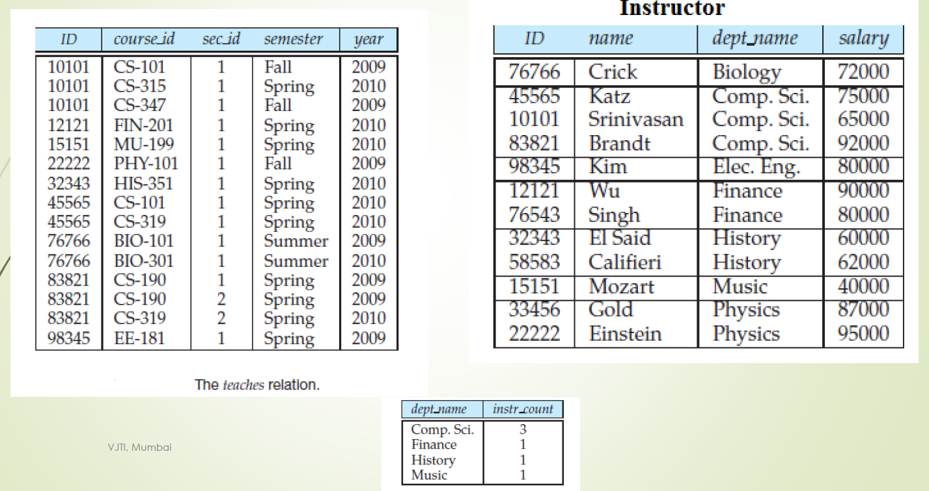

Find the number of instructors in each department who teach a course in theSpring 2010 semester

SELECT dept_name ,count(ID) from Instructor

NATURAL JOIN teaches

WHERE teaches.year = 2010

AND teaches.semester = 'Spring'

GROUP BY dept_name;

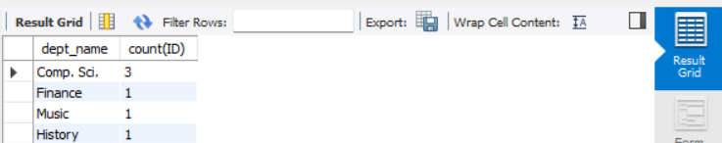

Department name where the average salary of the instructors is more than $42,000.

SELECT dept_name, avg(salary) as avg

FROM Instructor

GROUP BY dept_name

HAVING avg > 42000

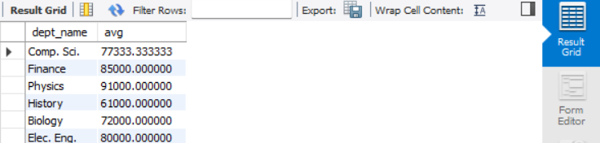

HAVING IS USED AFTER GROUP BY

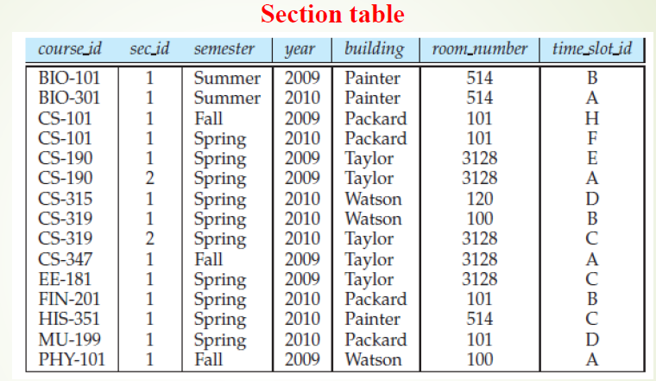

Find all the courses taught in the both the Fall 2009 and Spring 2010 semesters.

SELECT course_id

FROM course_sections

WHERE year = 2009 and semester = 'Fall' and

course_id IN (

SELECT course_id

FROM course_sections

WHERE year = 2010 and semester = 'Spring'

) ;

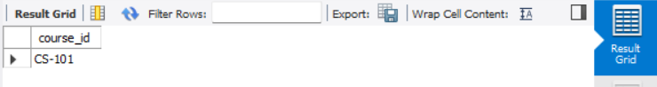

Find all the courses taught in the Fall 2009 semester but not in the Spring 2010semester.

SELECT course_id

FROM course_sections

WHERE year = 2009 and semester = 'Fall' and

course_id NOT IN (

SELECT course_id

FROM course_sections

WHERE year = 2010 and semester = 'Spring'

) ;

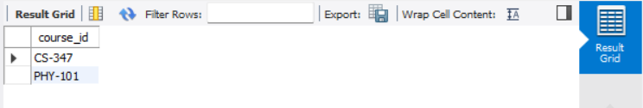

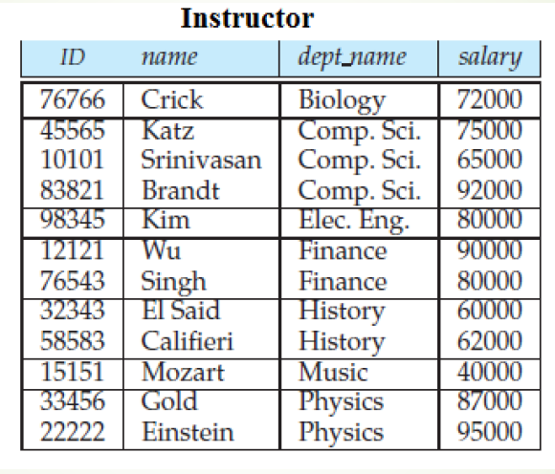

Find the names of all instructors whose salary is greater than at least one instructor in the Biology department

SELECT T.name

FROM Instructor AS T, Instructor AS S

WHERE T.salary > S.salary AND S.dept_name = 'Biology';

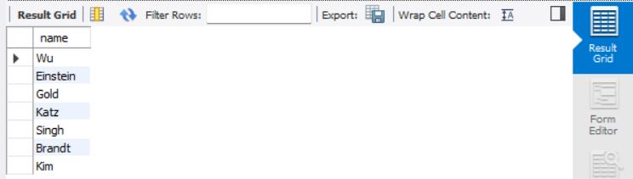

-OR- VIA NESTED QUERY

SELECT NAME FROM Instructor

WHERE salary > (SELECT salary FROM INSTRUCTOR WHERE dept_name = 'Biology' ) ;

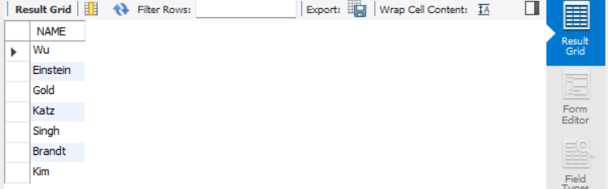

Find the department that have the highest average salary.

SELECT dept_name , avg(salary) as salary FROM Instructor

GROUP BY dept_name

HAVING salary = max(select avg (salary)

from instructor

group by dept name);

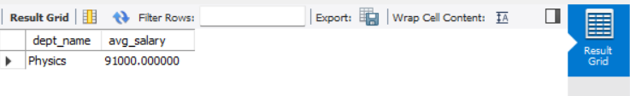

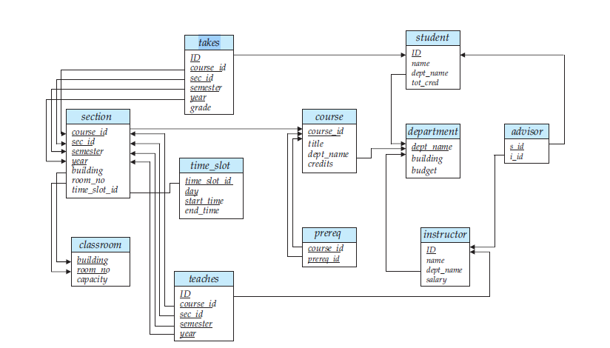

Find the titles of courses in the Comp.Sci. department that have 3credits

SELECT course_id FROM course WHERE credits = 3

Find the highest salary of any instructor.

SELECT max(salary) FROM instructor

Find all instructors earning the highest salary.

select ID from instructor

where salary = (select max(salary) from instructor)

Find the enrolment (count) of each section that was offered in Autumn 2009

SELECT sec_id, COUNT(course_id)

NATURAL JOIN TAKES

WHERE takes.year= 2009 semester = ’Autumn’

GROUP BY sec_id

Find the maximum enrolment, across all sections, in Autumn 2009.

SELECT max(enrolment) FROM

(SELECT sec_id , count(course_id) as enrolment

FROM section INNER JOIN takes

WHERE year = 2009 and semester = ‘Autumn’)

For each course section offered in 2009, find the average total credits (*tot cred*) of all students enrolled in the section, if the section had at least 2 students.

SELECT

t.sec_id AS section,

AVG(s.tot_cred) AS avg_total_credits

FROM

takes AS t

NATURAL JOIN

student AS s

WHERE

t.year = 2009

GROUP BY

t.sec_id

HAVING

COUNT(DISTINCT t.ID) >= 2;